# 3. Spectral Illustration

## 3.1 Signal Generation

Generate the signal x

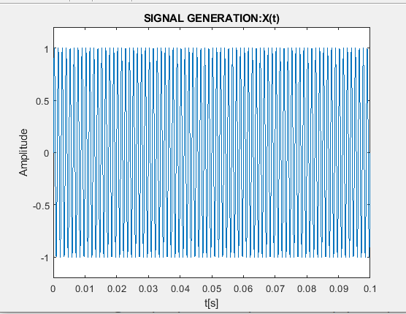

Two‐sided amplitude spectrum of x:

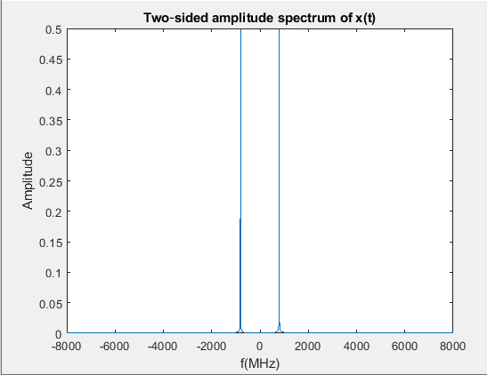

## 3.2 Multiplication between two signals

Multiply the x and m signals s

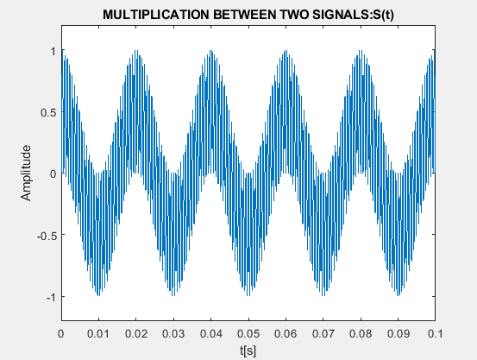

Two‐sided amplitude spectrum of s(t)

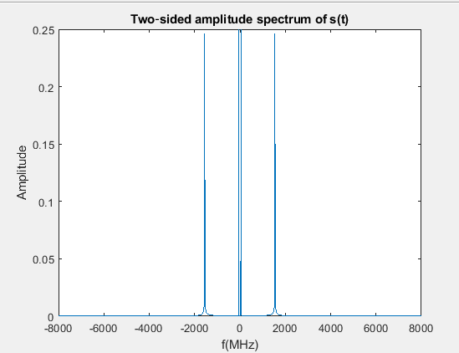

## 3.3 Adding a Noise Signal

Noisy Signal :

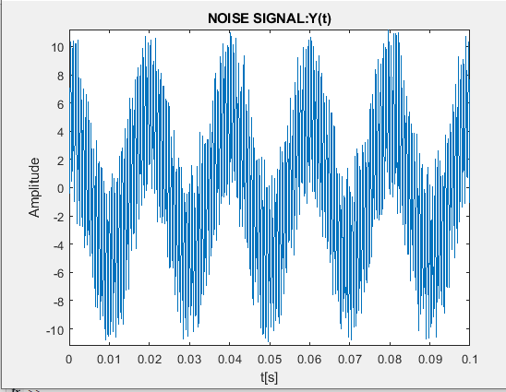

Two‐sided amplitude spectrum of y(t)

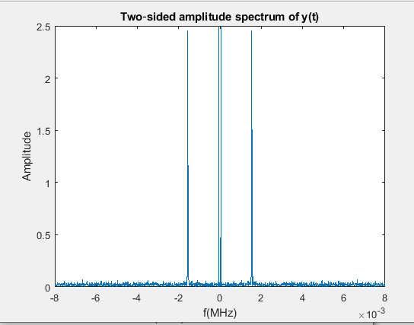

# 4. LINEAR FILTERING

## 4.1 Low Pass Butterworth Filter

Frequency response of the filter

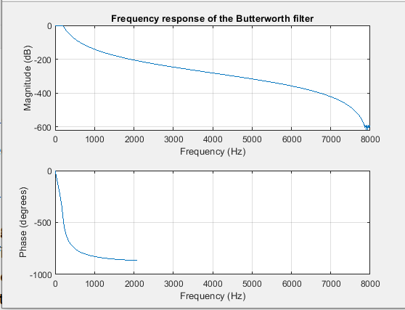

Filtered signal in time domain

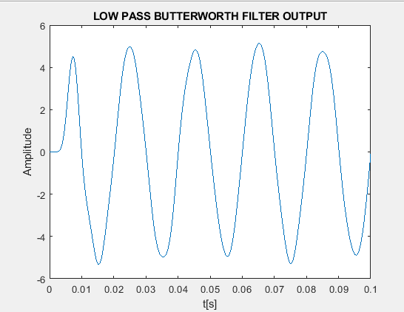

Filtered signal in frequency domain

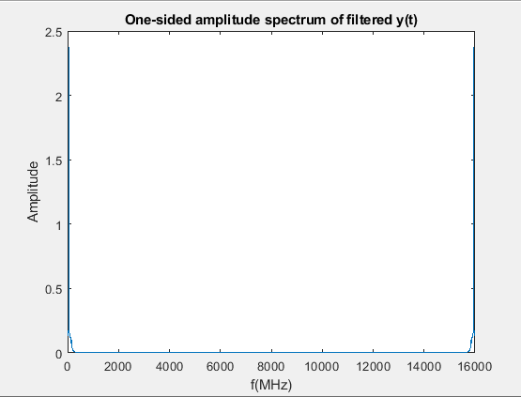

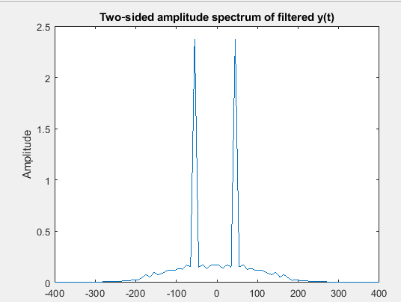

## 4.2 Band Pass FIR Filter

Impulse response of the filter

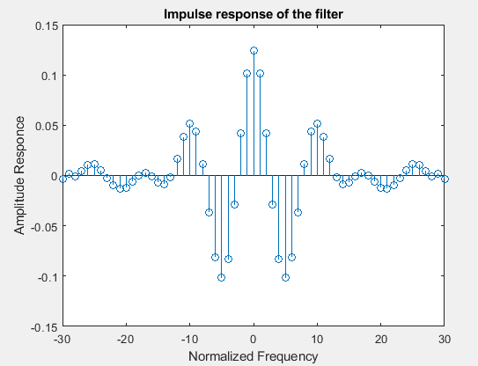

Amplitude response of the filter

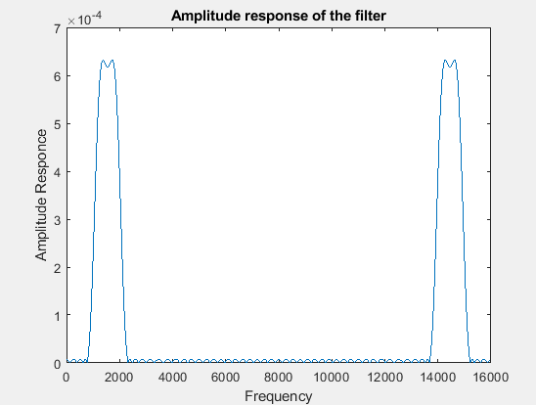

Filtered signal in time domain

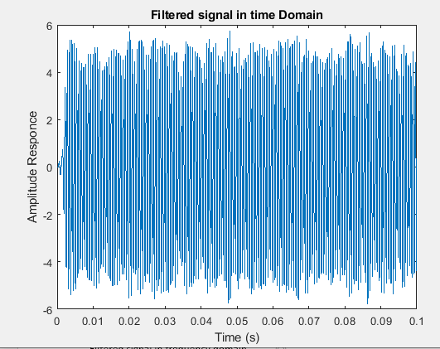

Filtered signal in frequency domain

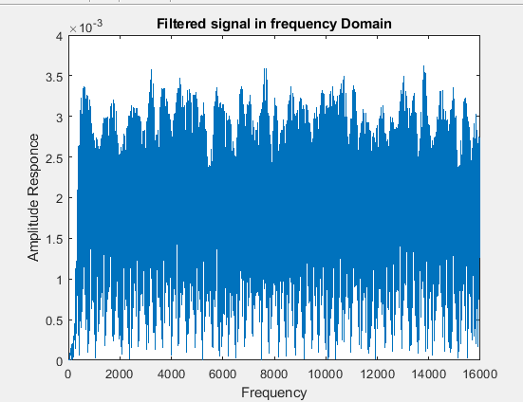

# Matlab Codes

## Class room exercise



## Homework Assignment

